See here we will be given a word and we need to make sure that after reorganization no 2 letter are adjacent.

this can be the solution.

Now let discuss the logic for the solution of this question.

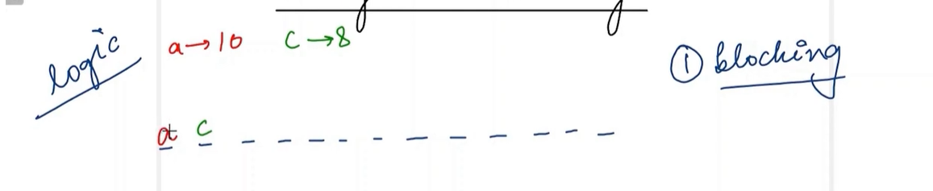

See here a are 10 times and c is 8.we need to decide which on to pick using the frequency.

See consider this here (a) is 2 times and (b) is 1 time. Hence first (a) should be printed in array as max frequency. But now (a) is also 1 and (b) is also 1.now (b) will be printed and then (a) again printed.

See here we did the opposite, and this does not work. Hence, we know that max frequency should be first priority.

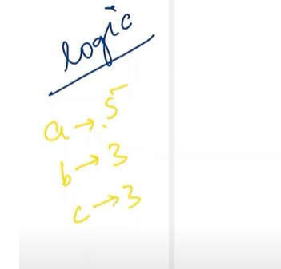

Now we see we get another string like the above.

See we will take the max frequency element and place it inside a variable block.

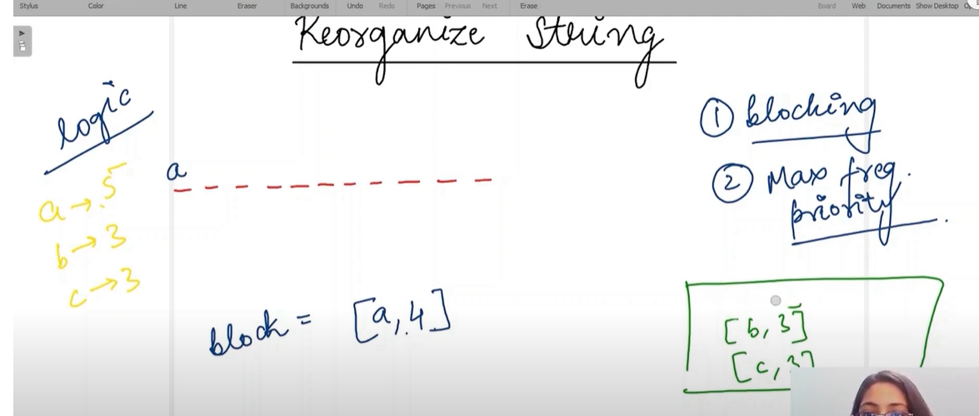

Put a from max frequency into the string. Again take temp variable and take the second maximum

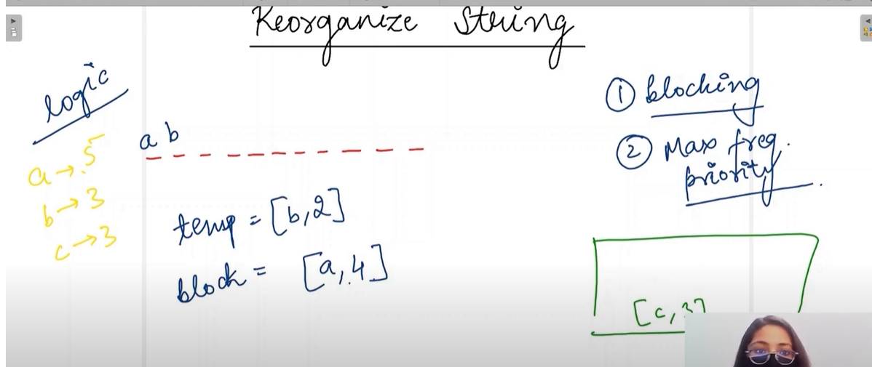

Now put the second most frequency in the string and reduce its frequency. See now temp will be (a) and block will be =b. See block represent the element to be put on string and temp represent the next letter to be checked to put in string.

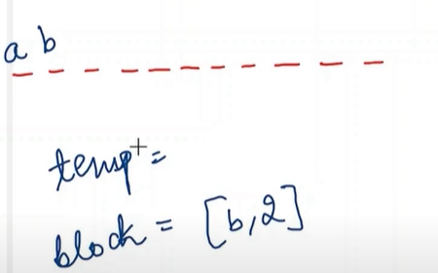

See when we put (b) in the index 1 this will be the value of block b. See we will put a,4 for again to the heap and check the max value and put it in the temp .

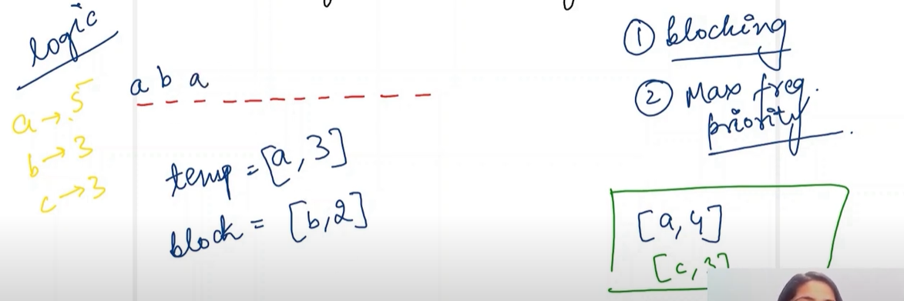

See here max is a and hence put a in string and remove it. see now b,2 insert in heap and check the now maximum which will be c,3.see we see every time u put the letter insert this again to heap and find the next to next string to be put inside the string.

See consider above

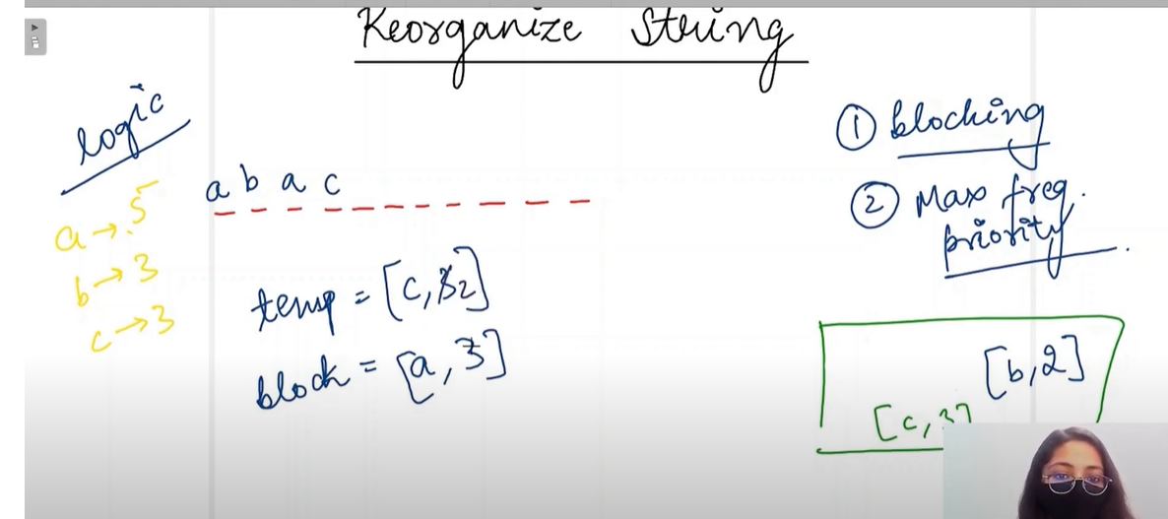

**IMP-see here consider we took c,3 to be put in the string so we put the c and reduce it frequency. Now next variable contain a, 3.put a,3 back to heap and then take the top and store it for the letter next to be put. After that put take c,2 insert into the heap and again take the top. See this is happening.**

But what happens if (aaab) this is given. Now what will happen.

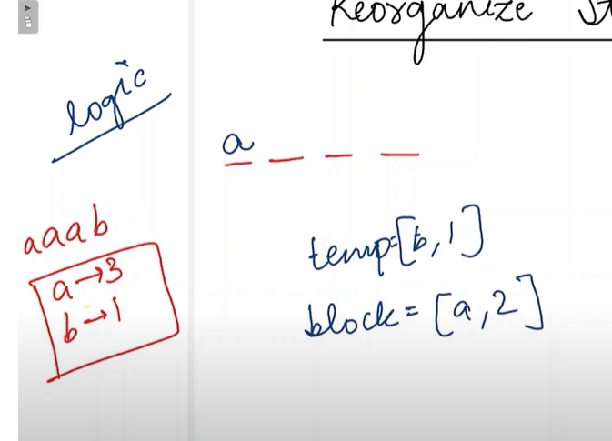

Now we will take b,1 and put it inside the string, now put a inside the heap and take the top. Now a,2 will come and same process as above but after putting a inside the string. see b,0 is there. See now when pop heap is empty but a,1 there still hence can’t make it.

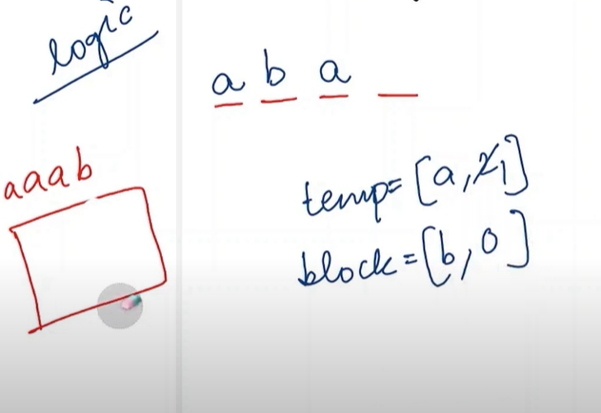

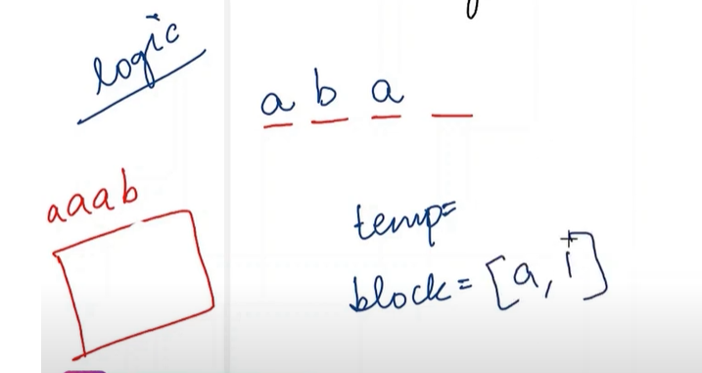

See here a,1 remain but we can’t put that a inside string as adjacent are same.

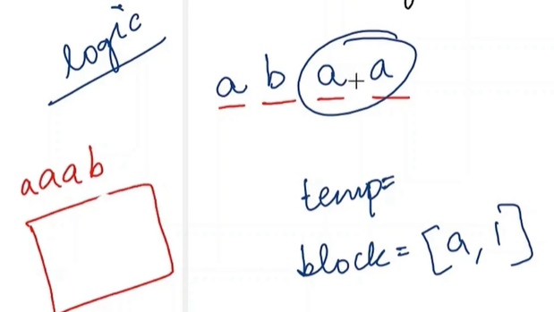

Wrong.

Pseudo code:

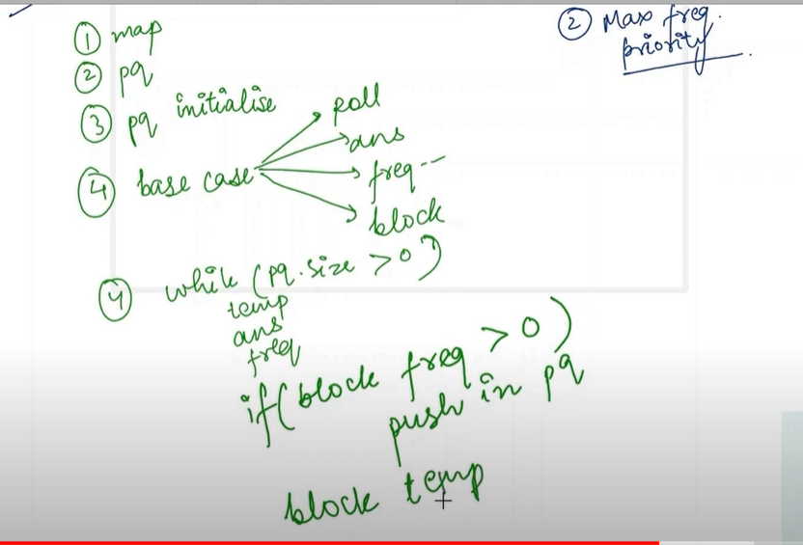

Main code:



